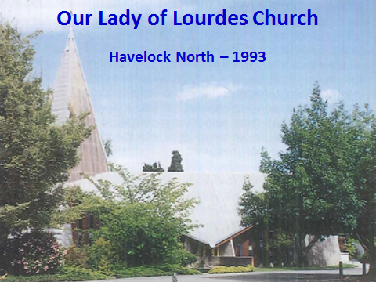 |  | Some history:  - John Scott’s model of the proposed Church produced vociferous objections locally  - John’s 1970 Presbytery design was likened to African huts  - The altar area in the Church has been reconfigured twice since the Second Vatican Council in the early 1960’s  - John also designed the Parish Centre (opened in 1987)  - The Church was recognised by a New Zealand Institute of Architects Enduring Architecture Award in 2010 as being "a major work by one of New Zealand's most significant architects."  These notes were prepared by Mark von Dadelszen, 2015
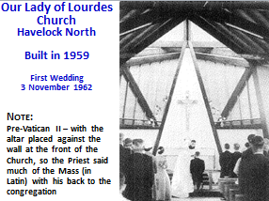 |  |  |  | 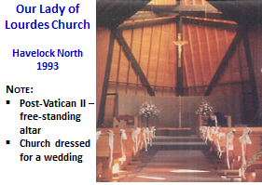
Our Lady of Lourdes Church  Notes:  - On the left, John Scott’s sketches for the redesigned altar area, with a circular screen and strong echoes of the structural skeleton  - Compare that sketch with the reconfigured Futuna Chapel (centre) and the eventual 2007 changes at Our Lady of Lourdes (right) designed by Jacob Scott and Karl Wixon | 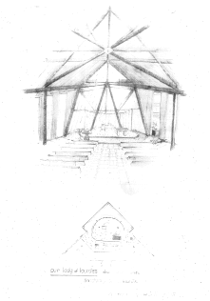 |  |  |  | 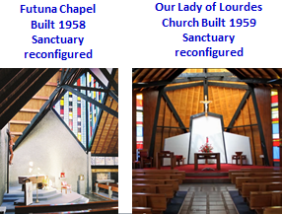
Our Lady of Lourdes Church  2007  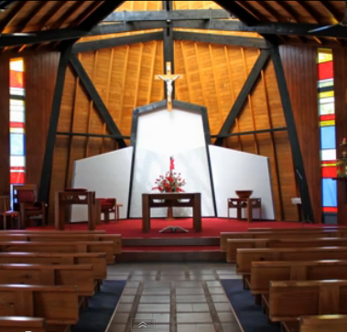 |  |  | Notes to the 2007 Refurbishment:  - Altar area re-designed by Jacob Scott and Karl Wixon  - New screen behind the altar, with its rough-cast central wall echoing the rough-cast buttresses at the Church entrance  - Screen wing walls angles matching the main structure  - Immersion baptismal font lowered to floor level  - Faded and damaged coloured window panels replaced  - Free-standing altar, with other furniture to match (Rimu altar, lectern, chair and baptismal font tables designed by Judy Marshall, and Kauri baptismal bowl turned by Mark von Dadelszen)  - Altar area re-carpeted  - Original pews retained (with carpet installed under the pews)  - Original paved aisles retained  - Interior timber finishes refurbished  - Mosaic of Our Lady commissioned by John Scott installed above the entrance to the Church (gift of his widow)  - Sound system installed

